**Hello World RESTful Web Service**

**url:** [**http://localhost:8083/hello**](http://localhost:8083/hello)

**chrome browser:**

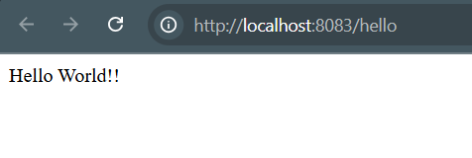

**Postman:**

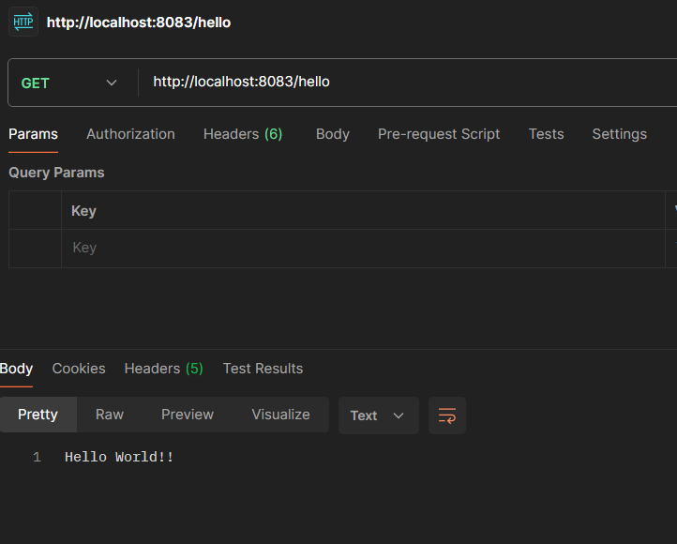

**SME to explain the following aspects:**

* **In network tab of developer tools show the HTTP header details received**
* **In postman click on "Headers" tab to view the HTTP header details received**

**Chrome Developer Tools (Network Tab)**

1. Open Chrome → Go to http://localhost:8083/hello
2. Right-click → **Inspect** → Click **Network** tab
3. Reload the page (F5)
4. Click on /hello → Go to **Headers** tab

You’ll see:

* **Request Headers**:
  + Host, User-Agent, Accept, etc.
* **Response Headers**:
  + Content-Type: text/plain;charset=UTF-8
  + Content-Length: 13
  + Date, Server

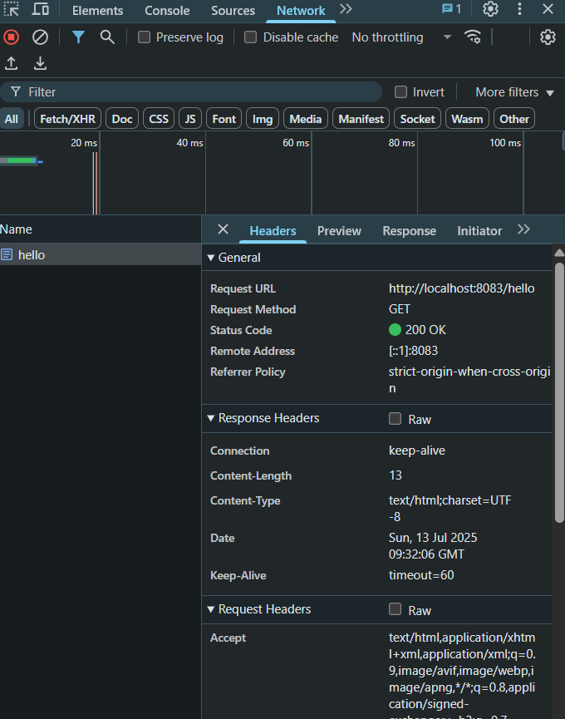

**Postman (Headers Tab)**

1. Open Postman → Send GET http://localhost:8083/hello
2. Click **Headers** tab (below response)

You’ll see:

* Content-Type, Content-Length, Date, etc. in response
* User-Agent, Accept, Host in request

